STAGE-I- PROJECT REPORT
on
"CHATBOT IN FOOD INDUSTRY"
By
GROUP NO.
VARNIKA PRASAD 116A2114
ROHIT VISHWAKARMA 116A2117
KUNAL HADKAR 215A2132

UNDER THE GUIDANCE OF
Prof. PREETI HEMNANI

SUBMITTED IN PARTIAL FULFILLMENT FOR THE DEGREE OF
BACHELOR OF ENGINEERING
In
ELECTRONICS AND TELECOMMUNCATION.

DEPARTMENT OF ELECTRONICS AND TELECOMMUNICATION
SIES GRADUATE SCHOOL OF TECHNOLOGY
NERUL, NAVI MUMBAI – 400706
ACADEMIC YEAR
2019– 2020

CERTIFICATE
This is to certify that this is a bonafide record of Project Stage-I of the project titled “Chatbot in Food Industry” carried out by the following students of final year in Electronics and Telecommunication Engineering.
Sr. No. Name Roll No.
1. Varnika Prasad 116A2114
2. Rohit Vishwakarma 116A2117
3. Kunal Hadkar 215A2132
The report is submitted in partial fulfillment of the degree course of Bachelor of Engineering in Electronics and Telecommunication of University of Mumbai during the academic year 2019-2020.

Internal Guide Head of Department Principal

We have examined this report as per University requirements at SIES Graduate School of Technology, Nerul (E), Navi Mumbai on ____________.

Name of External Examiner: ___________________________________________
Signature with Date: _____________________________

Name of Internal Examiner: ___________________________________________
Signature with Date: _____________________________

ACKNOWLEDGEMENT
We offer our profound gratitude to the management for giving us this opportunity of amalgamating our theoretical knowledge with practical experience, in a creative way.
The knowledge that we got from the project work filled us with huge confidence of always thinking in creative manner. This experience is unparalleled to any other form of learning.
We would like to thank our project guide and mentor Prof. Preeti Hemnani for her invaluable guidance, contribution and motivation during our project. We also want to thank our HOD, Dr. Atul Kemkar and all the teachers for their support in helping us in solving any kind of difficulty.

CONTENTS

Sr.No. | Topic | Page No.
1. | Abstract | 4
2. | List of Tables or Figures | 4
3. | w Introduction | 5
4. | Need of Project | 6
5. | Literature Survey | 7
6. | Objective/Objectives | 11
7. | Methodology | 11
8. | Experimental/Modeling/Designing/Programming/data collection etc. till date | 13
9. | References | 19

Abstract:
In this project, an AI based bot which can closely imitate natural human language, behavior and produce formidable replies to the conversations held with it, is to be designed. The project moreover emphasizes more on the application of chatbot in a particular domain. We’ve chosen ‘food industry’ as the domain for our conversational bot. In this project, an attempt will be made to develop the bot in such a way that resemblance to human conversations is maximum and the bot to deliver an instant desired reply to any reasonable and sufficient input given to it.
The proposed bot is to be designed using Python and a number of its libraries or modules. The bot can be a good candidate not only in the selected domain but a number of other fields such as banking, airport and railway systems, hospital systems, etc.
Chatbots, nowadays have become very popular due to their sheer ability to replace humans in most of the industrial scenarios. So, considering its importance in the outside world as per the progress of Artificial Intelligence and Machine Learning systems, we chose this project so as to get hands-on knowledge and hone our skills.

List of images/figures:
- ELIZA cover page.
- ELIZA’s founder Joseph Wiezumbaum doing a test run.
- ALICE having a conversation with a user.
- Founder of ALICE- Shamim-Al-Mamum.
- Barista Bot by Starbucks- the global food brand.
- Food brands like Dominos’ and Whole foods which make use of chatbots.
- Anatomy of a chatbot.
- Wordnet logo.
- NLTK-NLP processes involved for text processing.
- Popular chatbots with good UIs in the market.

4
Introduction:
A chatbot is an autonomous conversational agent where a computer program is designed to simulate an intelligent conversation. Techopedia has defined chatbots as- ‘A chatbot is an artificial intelligence (AI) program that simulates interactive human conversation by using key pre-calculated user phrases and auditory or text-based signals.’ It can take user input in many formats like text, voice, sentiments, etc. Chatbots, nowadays have replaced humans in industries in order to reduce manpower and reduce costs for the companies.
There has been a tremendous usage of technology in the past two decades or so since the Internet really flourished and computer systems replaced almost every other thing in the world. Now, companies are not only trying to improve the supplies but also to reduce the manpower required for tasks and thus cut costs. This has become possible by the usage of these conversational bots or talk-bots as they call them too, which are improving time efficiencies along with giving industries the opportunity to reduce costs. As far as food industries or restaurants/cafes are concerned, an attempt is being made to provide service to the customers as soon as they arrive at a table thus not making them to wait for the waiters for long periods of time. This can be done by installing chatbots at the tables and the customers can order their stuff or even get the menu checked. The bot then behaves just like a server and provides required service and passes on the message to the chef/manager.
The idea to train a chatbot as per the company or individual’s requirements is by feeding the bot with conversational logs and then the bot makes use of Data Science or Machine Learning to extract desired information at a very fast rate as per the question asked to it by the user and performs mapping of words or phrases as per the requirement.

5
Need of Project:
Food industries or restaurants with higher number of customers, especially during peak hours, really find it difficult to cope up with the incoming traffic and also deal with home delivery orders, etc. at the same time. Longer waiting time to serve customers leads to the bigger problem of losing them in future. Technology though nowadays, with the flourishment of Data Science, can help with this.
Nowadays, companies are not only trying to improve the supplies but also to reduce the manpower required for tasks and thus cut costs. This has become possible by the usage of these conversational bots or talk-bots as they call them too, which are improving time efficiencies along with giving industries the opportunity to reduce costs. As far as food industries or restaurants/cafes are concerned, an attempt is being made to provide service to the customers as soon as they arrive at a table thus not making them to wait for the waiters for long periods of time. This can be done by installing chatbots at the tables and the customers can order their stuff or even get the menu checked. The bot then behaves just like a server and provides required service and passes on the message to the chef/manager.
Chatbots can also be used for delivery systems wherever manpower isn’t ample and delivery requirement is on a larger scale. Suppose, a customer wants to order a pizza. He/she can simply call his/her favorite pizza center and get it done. But what if phone lines are busy or not working due to some reason? Bots can come into play then. The person can simply then go to the center’s website or use their application and converse with the bot designed by them and get his order done.
The use of chatbots in fast food outlets and restaurants will have an instrumental impact on the way the industry interacts with customers and processes orders. Chatbots not only speed up interactions, encourage more sales and build brand loyalty, but they also ensure a brand stays current in a diverse and digital market.

6
Literature Survey:
ELIZA is considered as the first chatbot which works on the pattern matching system. It was developed by Joseph Weizenbaum in 1964. Her purpose was to show the superficiality of communication between man and machine. She did this by recognizing keywords and asking about them as if she were a psychotherapist. For example, if someone mentioned their mother in a sentence, Eliza would automatically ask them to tell her more about their family. In this way, an illusion of real understanding and interaction was created. Eliza’s answers were so convincing that when chatting with her for the first time, some people thought they were talking to a human. However, one would soon realize that there was a limit when the user encountered implicit or subliminal messages in Eliza’s responses that didn’t really exist or didn’t have the right meaning. At this point, the conversation became incoherent. Another flaw was that she couldn’t memorize and learn from her conversations.
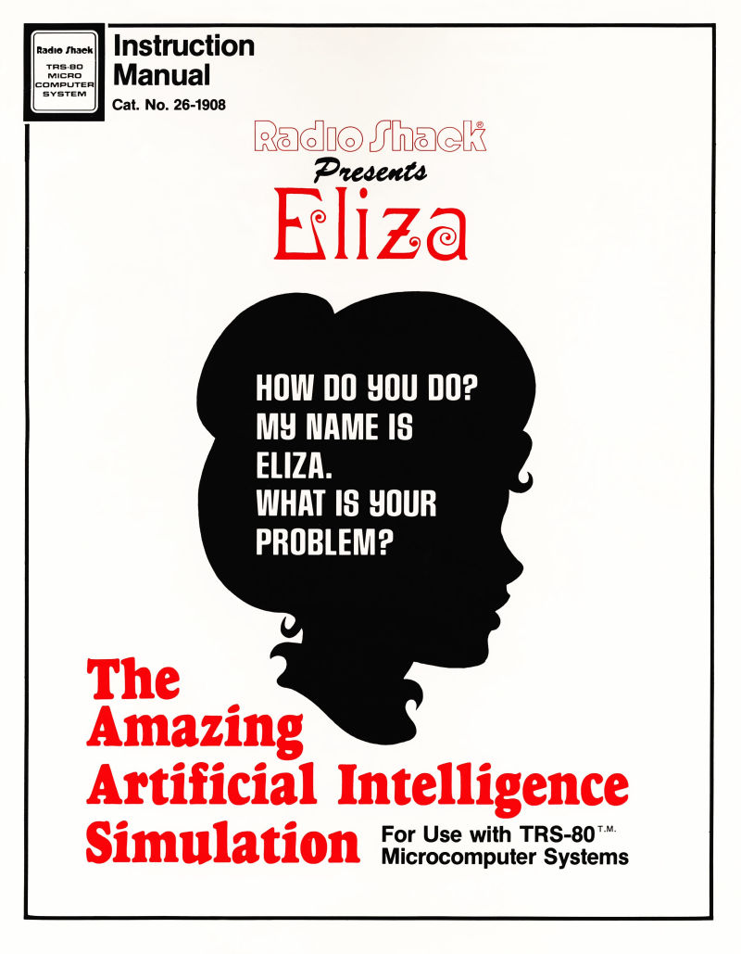

7
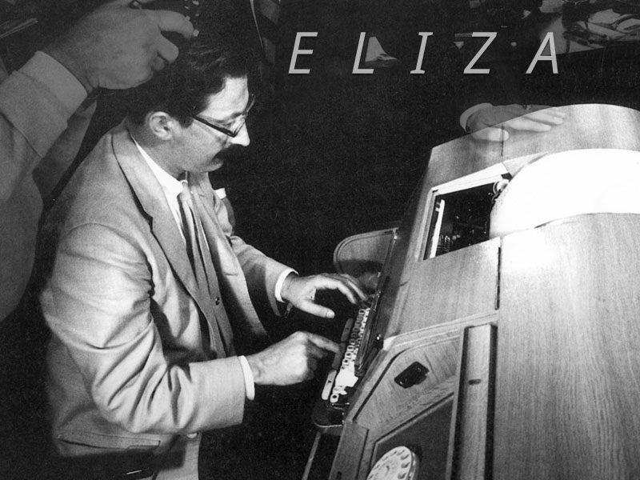

A.L.I.C.E(Artificial Linguistic Internet Computer Entity) is rule-based chatbot based on the Artificial Intelligence Markup Language (AIML). It has more than 40,000 categories, where each category has combination of pattern and its response. (A.L.I.C.E.) was originally written in Java and utilized an XML schema called AIML (Artificial Intelligence Markup Language). The aim of AIML, which was distributed with an open source license and has been implemented on a number of different platforms (i.e. Pandorabots), was to encourage other developers to modify the initial program and produce numerous Alicebot clones. A.L.I.C.E. won the restricted category Loebner Prize three times: in 2000, in 2001, and in 2004. This prize, initiated by Hugh Loebner in 1991, is “the first formal instantiation of the Turing Test”.
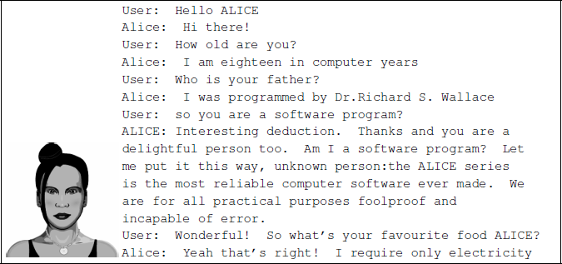
8
Md. Shahriare Satu and Shamim-AI-Mamun showed the review of applications of the Chatbot which are developed using the AIML scripts. They said that AIML based chatbots are easy to implement, they are lightweight and efficient to work. Their paper gives the detailed information about the different applications of the chatbots. A link for the paper has been mentioned in the ‘References’ section of this report.
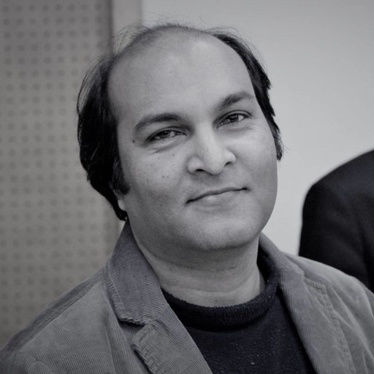
Shamim-Al-Mamun

Thomas N. T. and Amrita Vishwa designed a AIML and LSA based chatbot to provide the customer care service over the E- commerce websites. Their approach shows we can improve the chatbot ability by adding other models to it. In android operating system, we can implement the chatbot using the various approaches. One of the approaches is shown by Rushabh Jain and Burhanuddin Lokhandwala in their Android based Chat-Bot paper.

9
Global chain Starbucks introduced their Barista Bot last year on their app, allowing customers to quickly pre-order and pay for their drinks and skip the queue in-store. The chatbot might even spell your name right on your order!
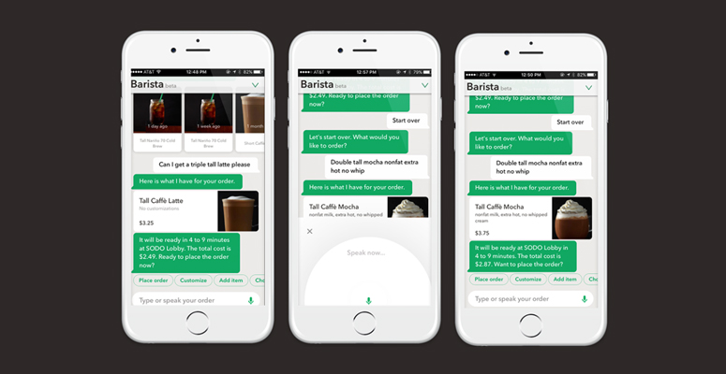
Photo Chat Bot Guide ©
In the US, supermarket brand Whole Foods launched their recipe bot to help customers decide their shopping list and recipes for the week. By using emojis instead of words, the chatbot speeds up interactions with customers and creates a unique experience with your brand for customers online. Perhaps one of the best-known influencers for AI in the food industry is Domino’s, who created their pizza-loving chatbot ‘DOM’ in 2014. Today, Domino’s now conducts more than 65 percent of its sales in the U.S. via numerous digital platforms including using DOM. With Domino’s DOM currently being tested to answer customer phone calls in America and KFC opening the first AI-only staffed branch in Shanghai, China, chatbots seem here to stay for the food industry with new and exciting possibilities.
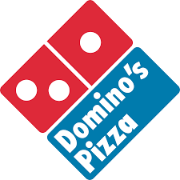

10
Objective:
The objective or attempt is to provide service to the customers in food industry or restaurants/cafes, etc. via conversational bots or simply called chatbots as soon as they arrive at a table thus not making them to wait for the waiters for long periods of time. This can be done by installing chatbots at the tables and the customers can order their stuff or even get the menu checked. The bot then behaves just like a server and provides required service and passes on the message to the chef/manager. As far as working of the bot is concerned, we will have to train the bot. The idea to train a chatbot as per the company or individual’s requirements is by feeding the bot with conversational logs and then the bot makes use of Data Science or Machine Learning to extract desired information at a very fast rate as per the question asked to it by the user and performs mapping of words or phrases as per the requirement. At Stage-1 level, the root objective is to extract keywords or key data from the dataset and then apply conditional statements and finally based on user input give approximate desired reply.

Methodology:
There are broadly two variants of chatbots: Rule-Based and Self-learning.
In a Rule-based approach, a bot answers questions based on some rules on which it is trained on. The rules defined can be very simple to very complex. The bots can handle simple queries but fail to manage complex ones. Self-learning bots are the ones that use some Machine Learning-based approaches and are definitely more efficient than rule-based bots. These bots can be of further two types: Retrieval Based or Generative.
i ) In retrieval-based models, a chatbot uses some heuristic to select a response from a library of predefined responses. The chatbot uses the message and context of the conversation for selecting the best response from a predefined list of bot messages. The context can include a current position in the dialogue tree, all previous messages in the conversation, previously saved variables (e.g. username). Heuristics for selecting a response can be engineered in many different ways, from rule-based if-else conditional logic to machine learning classifiers.
ii) Generative bots can generate the answers and not always replies with one of the answers from a set of answers. This makes them more intelligent as they take word by word from the query and generates the answers.

11
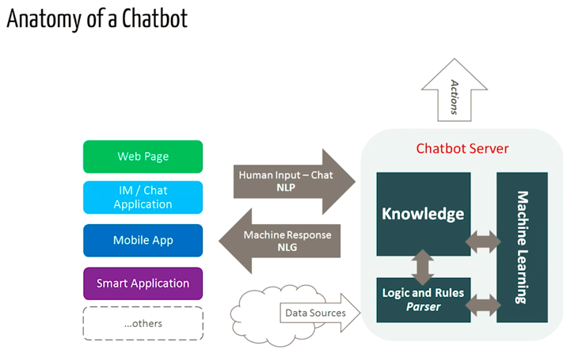

At Stage-1 level, the aim is to extract keywords or key data from the dataset and then apply conditional statements and finally based on user input give approximate desired reply. For this appropriate dataset is also required which can be obtained by surfing food sites and checking out user conversations while ordering food. Once the dataset with enough data is created or obtained we can then go with our flow of data extraction using NLTK library of python and expect replies from the bot. It should be noted here that at Stage-1 level, no training process is involved and the bot isn’t learning from its past experiences or conversations with the user. The bot is just working based on data manipulation and data extraction techniques.

12
Modelling and Programming/Building the Bot (till date):
The field of study that focuses on the interactions between human language and computers is called Natural Language Processing, or NLP for short. It sits at the intersection of computer science, artificial intelligence, and computational linguistics. NLP is a way for computers to analyze, understand, and derive meaning from human language in a smart and useful way. By utilizing NLP, developers can organize and structure knowledge to perform tasks such as automatic summarization, translation, named entity recognition, relationship extraction, sentiment analysis, speech recognition, and topic segmentation.
NLTK (Natural Language Toolkit) is a leading platform for building Python programs to work with human language data. It provides easy-to-use interfaces to over 50 corpora and lexical resources such as WordNet, along with a suite of text processing libraries for classification, tokenization, stemming, tagging, parsing, and semantic reasoning, wrappers for industrial-strength NLP libraries. NLTK has been called “a wonderful tool for teaching and working in, computational linguistics using Python,” and “an amazing library to play with natural language.” Natural Language Processing with Python provides a practical introduction to programming for language processing. A highly recommended book to people beginning in NLP with Python has also been mentioned in the ‘References’ section of this report.
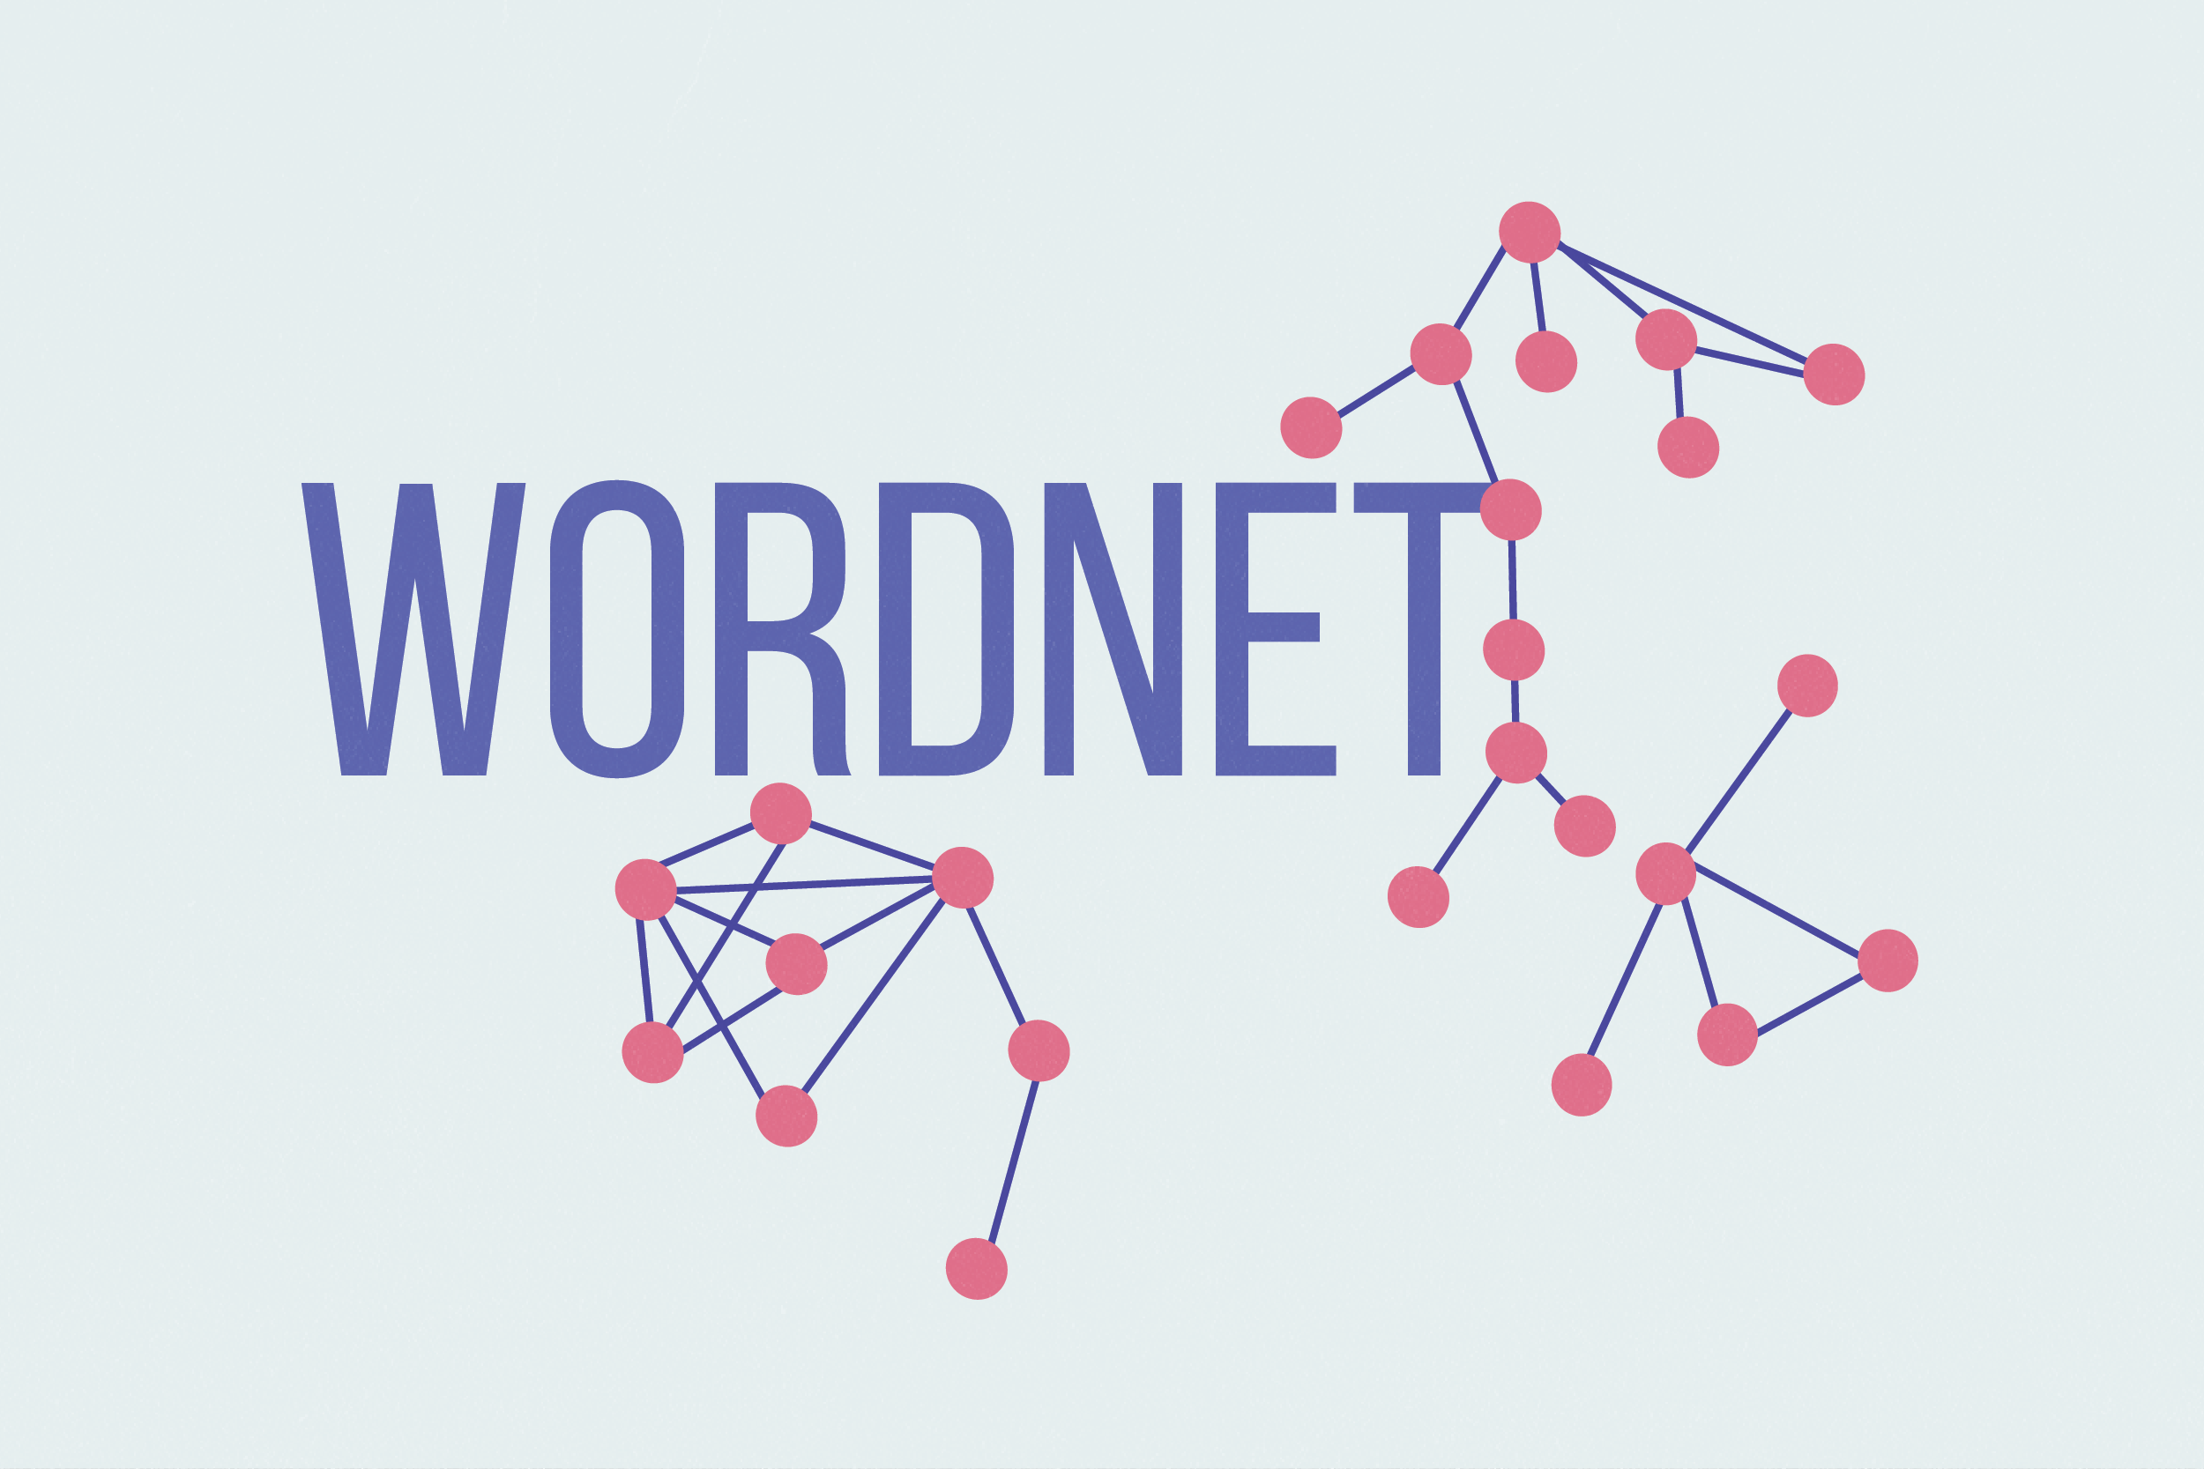

13
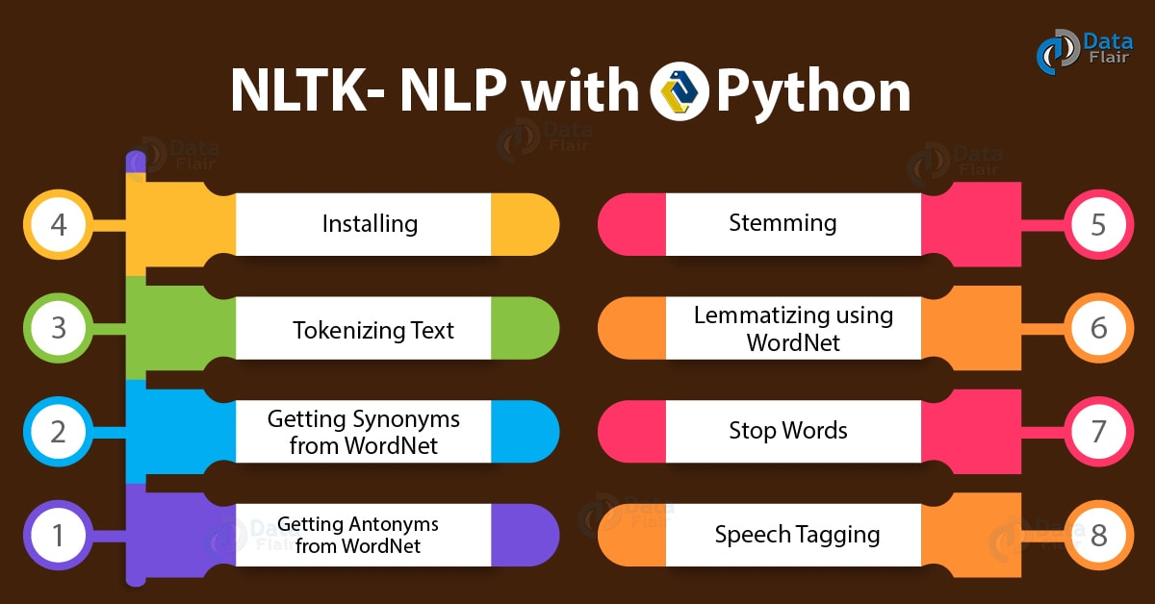

For working with things involving data manipulation and NLP, knowledge of NLTK and scikit library is important.
Downloading and installing NLTK: Install NLTK: run pip install nltk
Test installation: run python then type import nltk

Installing NLTK Packages
import NLTK and run nltk.download().This will open the NLTK downloader from where you can choose the corpora and models to download. You can also download all packages at once.

Text Pre- Processing with NLTK
The main issue with text data is that it is all in text format (strings). However, Machine learning algorithms need some sort of numerical feature vector in order to perform the task. So before we start with any NLP project we need to pre-process it to make it ideal for work. Basic text pre-processing includes:
- Converting the entire text into uppercase or lowercase, so that the algorithm does not treat the same words in different cases as different
- Tokenization: Tokenization is just the term used to describe the process of converting the normal text strings into a list of tokens i.e words that we actually want. Sentence tokenizer can be used to find the list of sentences and Word tokenizer can be used to find the list of words in strings. NLTK includes a pre-trained punkt tokenizer.
14
- Removing Noise i.e. everything that isn’t in a standard number or letter.
- Removing Stop words. Sometimes, some extremely common words which would appear to be of little value in helping select documents matching a user need are excluded from the vocabulary entirely. These words are called stop words.
- Stemming: Stemming is the process of reducing inflected (or sometimes derived) words to their stem, base or root form — generally a written word form. Example if we were to stem the following words: “Stems”, “Stemming”, “Stemmed”, “and Stemtization”, the result would be a single word “stem”.
- Lemmatization: A slight variant of stemming is lemmatization. The major difference between these is, that, stemming can often create non-existent words, whereas lemmas are actual words. So, your root stem, meaning the word you end up with, is not something you can just look up in a dictionary, but you can look up a lemma. Examples of Lemmatization are that “run” is a base form for words like “running” or “ran” or that the word “better” and “good” are in the same lemma so they are considered the same.
- Bag of Words:
After the initial preprocessing phase, we need to transform the text into a meaningful vector (or array) of numbers. The bag-of-words is a representation of text that describes the occurrence of words within a document. It involves two things:
i. A vocabulary of known words.
ii. A measure of the presence of known words.
Why is it is called a “bag” of words? That is because any information about the order or structure of words in the document is discarded and the model is only concerned with whether the known words occur in the document, not where they occur in the document.
The intuition behind the Bag of Words is that documents are similar if they have similar content. Also, we can learn something about the meaning of the document from its content alone.
For example, if our dictionary contains the words {Learning, is, the, not, great}, and we want to vectorize the text “Learning is great”, we would have the following vector: (1, 1, 0, 0, 1).

15
- TF-IDF Approach
A problem with the Bag of Words approach is that highly frequent words start to dominate in the document (e.g. larger score), but may not contain as much “informational content”. Also, it will give more weight to longer documents than shorter documents.
One approach is to rescale the frequency of words by how often they appear in all documents so that the scores for frequent words like “the” that are also frequent across all documents are penalized. This approach to scoring is called Term Frequency-Inverse Document Frequency, or TF-IDF for short, where:
Term Frequency: is a scoring of the frequency of the word in the current document.
TF = (Number of times term t appears in a document)/(Number of terms in the document)
Inverse Document Frequency: is a scoring of how rare the word is across documents.
IDF = 1+log(N/n), where, N is the number of documents and n is the number of documents a term t has appeared in.
Tf-IDF weight is a weight often used in information retrieval and text mining. This weight is a statistical measure used to evaluate how important a word is to a document in a collection or corpus.
Example: Consider a document containing 100 words wherein the word ‘phone’ appears 5 times. The term frequency (i.e., tf) for phone is then (5 / 100) = 0.05. Now, assume we have 10 million documents and the word phone appears in thousands of these. Then, the inverse document frequency (i.e., IDF) is calculated as log(10,000,000 / 1,000) = 4. Thus, the Tf-IDF weight is the product of these quantities: 0.05 * 4 = 0.20. Tf-IDF can be implemented in scikit learn as: from sklearn.feature_extraction.text import TfidfVectorizer
- Cosine Similarity
TF-IDF is a transformation applied to texts to get two real-valued vectors in vector space. We can then obtain the Cosine similarity of any pair of vectors by taking their dot product and dividing that by the product of their norms. That yields the cosine of the angle between the vectors. Cosine similarity is a measure of similarity between two
non-zero vectors. Using this formula we can find out the similarity between any two documents d1 and d2.
Cosine Similarity (d1, d2) = Dot product (d1, d2) / ||d1|| * ||d2||
where d1, d2 are two non-zero vectors.
16
Now, let us get going with the actual building process:
Firstly, we have imported the necessary libraries for data extraction and data manipulation processes. These include- nltk, numpy, sklearn, random and string libraries. Then for the dataset we have included typical conversations and other necessary information in a .txt file which is the ‘corpus’ for our project. Another important point to note here is that at this stage the bot isn’t learning things on its own and correcting its experienced mistakes which involves training process; it is just looking out for keywords related to the text we input and performs actions based on that. Also, we have named our bot- ‘Robo’.
Then, for the pre-processing to start we firstly read the corpus file and converted the entire corpus file into a list of sentences or a list of words. These are saved as sentence tokens or word tokens. Then lemmatization is performed i.e. we define a function called as LemTokens which returns ‘normalized tokens’ for the input tokens. After this process, ‘Greeting process’ of the bot is defined i.e. we define a function for a greeting by the bot i.e. if a user’s input is a greeting, the bot shall return a greeting response. ELIZA uses a simple ‘keyword matching’ for greetings. We have utilized the same concept here. A list here consists of probable greeting inputs from the user party and its response is also stored in a list which the bot will return to the user if it reads the input as a greet from his/her side.
Next and the most important part is generating responses from the bot after it has understood parameters of the data from the previous steps. To generate a response from our bot for input questions, the concept of ‘document similarity’ is used. So, we begin by importing the necessary modules- from sklearn library ‘TFidf Vectorizer’ module is imported to convert a collection of raw documents to a matrix of TFidf features. Also ‘cosine similarity’ module is imported from the same library. We have defined a function ‘response’ which searches the user’s utterance for one or more known keywords and returns one of several possible responses. If it doesn’t find the input matching any of the keywords, it returns a response:” I am sorry! I don’t understand you”. Finally, we have fed the lines that we want our bot to say while starting and ending a conversation depending upon the user’s input. The entire coding is done using Python 3.6 and PyCharm IDE for python is used.

17
A fair bit of questions and conversations are being answered and held by the bot within its ‘dataset’ reach. However, at this stage the results aren’t as satisfactory as one would like since training of the bot isn’t yet involved at this stage. Machine Learning and Deep Learning implementation is certainly in sight and a larger dataset is to be covered by the bot with these things being involved. Also, the ‘User-interface and User-friendliness’ part is to be considered since a good design always amplifies good mechanism enabling the bot to be of some market value.
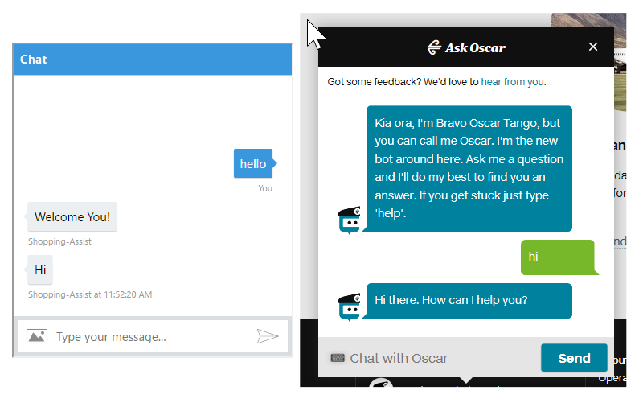
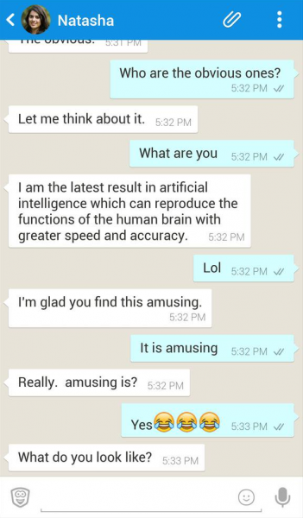
Chatbots with good UIs in the market

18

References:
https://www.iotforall.com/first-ai-chatbot-eliza/ for information on ELIZA.
https://analyticsindiamag.com/story-eliza-first-chatbot-developed-1966/ for ELIZA image.
https://www.masswerk.at/elizabot/ for actually having a conversation with ELIZA with code and image.
https://www.researchgate.net/figure/A-sample-conversation-with-ALICE-Shawar-and-Atwell-2007_fig3_265169196 for ALICE’s image.
https://www.academia.edu/33039598/Review_of_integrated_applications_with_AIML_based_chatbot for review of paper by Md. Shahriare Satu and Shamim-AI-Mamun.
https://www.researchgate.net/profile/Shamim_Al_Mamun2 for picture of Shamim Al Mamun
https://www.ijcaonline.org/research/volume137/number10/sayed-2016-ijca-908876.pdf for android based chatbot paper.
https://eat-marketing.co.uk/chatbots-and-food-industry/ for food industry information.
https://en.wikipedia.org/wiki/Whole_Foods_Market for whole foods logo.
https://medium.com/analytics-vidhya/building-a-simple-chatbot-in-python-using-nltk-7c8c8215ac6e for explanation.
http://nltk.org/book for book on Natural Language Processing in Python.
https://www.cs.princeton.edu/courses/archive/spring19/cos226/assignments/wordnet/specification.php for wordnet logo.
https://data-flair.training/blogs/nltk-python-tutorial/ for NLTK chart image.
https://en.wikipedia.org/wiki/NumPy for numpy image.
https://en.wikipedia.org/wiki/Scikit-learn for sklearn image.
https://stackoverflow.com/questions/44620604/edit-microsoft-chatbot-ui-design for chatbot with a good UI image.

19

20

